**truthiness in Python**

[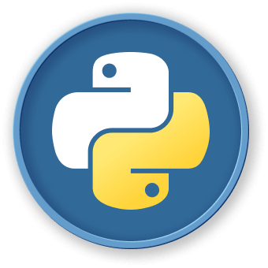Python](https://labex.io/skilltrees/python)Beginner



How to evaluate truthiness in Python

[Practice Now](https://labex.io/labs/python-test-if-some-list-elements-are-truthy-13717)

**Contents**

* [Introduction](https://labex.io/tutorials/python-how-to-evaluate-truthiness-in-python-462153#introduction)
* [Truthiness Fundamentals](https://labex.io/tutorials/python-how-to-evaluate-truthiness-in-python-462153#truthiness-fundamentals)
* [Conditional Evaluation](https://labex.io/tutorials/python-how-to-evaluate-truthiness-in-python-462153#conditional-evaluation)
* [Practical Truthiness Tips](https://labex.io/tutorials/python-how-to-evaluate-truthiness-in-python-462153#practical-truthiness-tips)
* [Summary](https://labex.io/tutorials/python-how-to-evaluate-truthiness-in-python-462153#summary)

[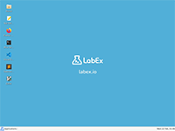Practice Now](https://labex.io/labs/python-test-if-some-list-elements-are-truthy-13717)

**Introduction**

Understanding truthiness is a fundamental skill in Python programming that enables developers to write more concise and elegant conditional statements. This tutorial explores how Python evaluates boolean contexts, revealing the nuanced ways objects are interpreted as true or false beyond traditional boolean values.

**Skills Graph**

Lab Skills

How to evaluate truthiness in Python

Booleans

Conditional Statements

Build-in Functions

Python

Functions

Basic Concepts

Control Flow

**Truthiness Fundamentals**

**What is Truthiness?**

In Python, truthiness is a concept that determines how different values are evaluated in boolean contexts. Every object in Python can be tested for its truth value, which helps developers write more concise and expressive code.

**Basic Truthiness Rules**

Python follows a set of fundamental rules when evaluating the truthiness of objects:

| **Value Type** | **Truthiness** | **Example** |
| --- | --- | --- |
| None | False | bool(None) == False |
| False | False | bool(False) == False |
| Zero values | False | bool(0) == False |
| Empty sequences | False | bool([]) == False |
| Non-zero numbers | True | bool(42) == True |
| Non-empty sequences | True | bool([1, 2, 3]) == True |

**Code Examples**

*## Demonstrating truthiness*

print(bool(0)) *## False*

print(bool(1)) *## True*

print(bool([])) *## False*

print(bool([1, 2, 3])) *## True*

print(bool(None)) *## False* Explain Code Practice Now

**Truthiness Evaluation Flow**

Yes

No

Object

Has Truthy Value?

Evaluates to True

Evaluates to False

**Advanced Truthiness Concepts**

Truthiness allows for more elegant control flow and conditional statements in Python. By understanding these principles, developers using LabEx can write more pythonic and efficient code.